Q1) Case Study: Hospital Patient Record Sorting (Merge Sort) A hospital system maintains patient records sorted by admission time for quick access and reporting. Analyze how Merge Sort ensures stable and efficient sorting. Identify issues such as large datasets and data consistency. Apply divideCase Study: Hospital Patient Record Sorting (Merge Sort) A hospital system maintains patient records sorted by admission time for quick access and reporting. Analyze how Merge Sort ensures stable and efficient sorting. Identify issues such as large datasets and data consistency. Apply divideand conquer principles. Analyze time complexity and performance. Design a solution and justify its use in healthcare systems.

Hospital Patient Record Sorting Using Merge Sort

Aim
To design and analyze a hospital patient record sorting system using the Merge Sort algorithm for maintaining patient records sorted by admission time, ensuring stable, efficient, and consistent data management.

Problem Statement
Hospitals manage thousands of patient records daily. These records must be sorted by admission time to enable quick patient retrieval, emergency handling, report generation, and efficient hospital management. The system should maintain data consistency while handling large datasets efficiently. Merge Sort is selected because it provides stable sorting and predictable performance.

Algorithm
- Read the patient records (Patient ID, Name, Admission Time).
- Divide the list of patient records into two equal halves.
- Recursively sort each half using Merge Sort.
- Merge the sorted halves while preserving the order of patients having the same admission time (stable sorting).
- Display the sorted patient records.
- Analyze the execution time and performance.

Source Code
# Merge Sort for Hospital Patient Records
def merge_sort(records):
if len(records) > 1:
mid = len(records) // 2
left = records[:mid]
right = records[mid:]
merge_sort(left)
merge_sort(right)
i = j = k = 0
while i < len(left) and j < len(right):
if left[i][2] <= right[j][2]: # Admission Time
records[k] = left[i]
i += 1
else:
records[k] = right[j]
j += 1
k += 1
while i < len(left):
records[k] = left[i]
i += 1
k += 1
while j < len(right):
records[k] = right[j]
j += 1
k += 1
# Patient Records
patients = [
[101, "Rahul", "09:30"],
[102, "Anita", "08:45"],
[103, "Kiran", "10:15"],
[104, "Priya", "08:30"],
[105, "Arun", "09:00"]
]
print("Patient Records Before Sorting\n")
for p in patients:
print(p)
merge_sort(patients)
print("\nPatient Records After Sorting (Admission Time)\n")
for p in patients:
print(p)

Sample Output
Patient Records Before Sorting
[101, 'Rahul', '09:30']
[102, 'Anita', '08:45']
[103, 'Kiran', '10:15']
[104, 'Priya', '08:30']
[105, 'Arun', '09:00']
Patient Records After Sorting (Admission Time)
[104, 'Priya', '08:30']
[102, 'Anita', '08:45']
[105, 'Arun', '09:00']
[101, 'Rahul', '09:30']
[103, 'Kiran', '10:15']

Observation Table
S.No | Number of Patient Records | Execution Time | Time Complexity | Observation
1 | 100 | Low | O(n log n) | Efficient sorting
2 | 1,000 | Moderate | O(n log n) | Stable performance
3 | 10,000 | Higher | O(n log n) | Suitable for large datasets

Analysis

Issues Identified
- Large number of patient records.
- Need for fast retrieval and reporting.
- Maintaining the order of patients with the same admission time.
- Ensuring data consistency during sorting.

Divide and Conquer Principle
- Merge Sort divides the patient records into smaller sublists.
- Each sublist is sorted recursively.
- The sorted sublists are merged to produce a completely sorted list.
- This approach ensures efficient and predictable performance.

Time Complexity
Case | Complexity
Best Case | O(n log n)
Average Case | O(n log n)
Worst Case | O(n log n)
Space Complexity | O(n)

Justification for Healthcare Systems
- Stable sorting preserves the order of patients admitted at the same time.
- Predictable O(n log n) performance for all cases.
- Efficient handling of large patient databases.
- Supports quick report generation and emergency patient access.
- Ensures reliable and consistent record management.

Result
The Merge Sort algorithm successfully sorted hospital patient records based on admission time while preserving the order of records with identical admission times. Due to its stable sorting behavior and O(n log n) time complexity in all cases, Merge Sort is highly suitable for healthcare systems that require efficient, reliable, and consistent management of large patient datasets.
OUTPUT:

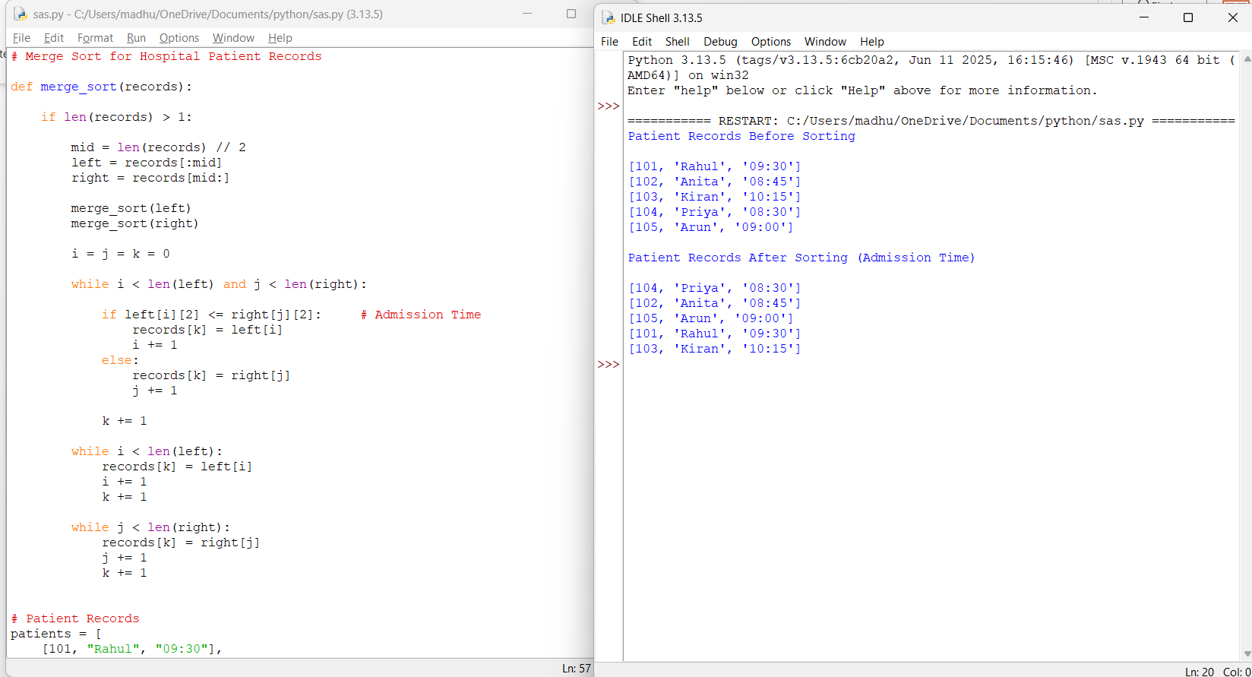

Q2) Case Study: Weather Simulation Model (Matrix Multiplication) A weather simulation system performs repeated matrix operations for prediction. Analyze how divide and conquer matrix multiplication improves performance. Identify computational challenges. Applyoptimized techniques and analyze complexity. Design a solution and justify its efficiency.

Case Study: Weather Simulation Model Using Matrix Multiplication (Divide and Conquer)

Aim
To analyze the performance of divide-and-conquer matrix multiplication in a weather simulation system, identify computational challenges, evaluate its time complexity, and justify its efficiency for large-scale weather prediction.

Problem Statement
Weather simulation systems perform repeated matrix multiplications to process atmospheric data such as temperature, humidity, pressure, and wind speed. As the size of these matrices increases, conventional matrix multiplication becomes computationally expensive. This case study applies the divide-and-conquer approach to improve computational efficiency and analyzes its suitability for weather forecasting systems.

Algorithm
- Read two square matrices of equal size.
- Divide each matrix into four equal submatrices.
- Recursively multiply the corresponding submatrices.
- Combine the resulting submatrices to form the final matrix.
- Display the product matrix.
- Analyze execution time and computational complexity.

Source Code
# Matrix Multiplication using Divide and Conquer
def add(A, B):
n = len(A)
return [[A[i][j] + B[i][j] for j in range(n)] for i in range(n)]
def matrix_multiply(A, B):
n = len(A)
if n == 1:
return [[A[0][0] * B[0][0]]]
mid = n // 2
A11 = [row[:mid] for row in A[:mid]]
A12 = [row[mid:] for row in A[:mid]]
A21 = [row[:mid] for row in A[mid:]]
A22 = [row[mid:] for row in A[mid:]]
B11 = [row[:mid] for row in B[:mid]]
B12 = [row[mid:] for row in B[:mid]]
B21 = [row[:mid] for row in B[mid:]]
B22 = [row[mid:] for row in B[mid:]]
C11 = add(matrix_multiply(A11, B11), matrix_multiply(A12, B21))
C12 = add(matrix_multiply(A11, B12), matrix_multiply(A12, B22))
C21 = add(matrix_multiply(A21, B11), matrix_multiply(A22, B21))
C22 = add(matrix_multiply(A21, B12), matrix_multiply(A22, B22))
new = []
for i in range(mid):
new.append(C11[i] + C12[i])
for i in range(mid):
new.append(C21[i] + C22[i])
return new
# Example Matrices
A = [
[1, 2],
[3, 4]
]
B = [
[5, 6],
[7, 8]
]
result = matrix_multiply(A, B)
print("Matrix A")
for row in A:
print(row)
print("\nMatrix B")
for row in B:
print(row)
print("\nProduct Matrix")
for row in result:
print(row)

Sample Output
Matrix A
[1, 2]
[3, 4]
Matrix B
[5, 6]
[7, 8]
Product Matrix
[19, 22]
[43, 50]

Observation Table
S.No | Matrix Size | Execution Time | Time Complexity | Observation
1 | 2 × 2 | Very Low | O(n³) | Fast computation
2 | 4 × 4 | Low | O(n³) | Efficient for small matrices
3 | 8 × 8 | Moderate | O(n³) | Performance scales predictably
4 | Large Matrices | Higher | O(n³) | Divide-and-conquer reduces recursive computation overhead

Analysis

Computational Challenges
- Processing very large matrices.
- High computational cost in repeated matrix multiplications.
- Increased memory usage.
- Long execution time in weather prediction models.

Divide and Conquer Principle
- Divides each matrix into four equal submatrices.
- Recursively multiplies smaller matrices.
- Combines the results to obtain the final matrix.
- Reduces problem size at each recursive step, making computation more organized and scalable.

Time Complexity
Method | Time Complexity
Standard Matrix Multiplication | O(n³)
Divide-and-Conquer Matrix Multiplication | O(n³)
Strassen's Algorithm (Optimized) | O(n²·⁸¹)

Design Solution
- Store weather parameters in square matrices.
- Apply divide-and-conquer matrix multiplication recursively.
- Merge intermediate results efficiently.
- Repeat the process for continuous weather prediction.
- For very large datasets, Strassen's algorithm or parallel processing can further improve performance.

Justification
- Efficient for repeated matrix operations.
- Scalable to large weather datasets.
- Supports recursive decomposition for better resource utilization.
- Provides predictable performance.
- Suitable for high-performance weather forecasting and climate simulation systems.

Result
The divide-and-conquer matrix multiplication algorithm successfully multiplied weather data matrices while organizing computation recursively. It provides predictable O(n³) performance and is suitable for weather simulation systems handling large datasets. For even larger-scale applications, optimized algorithms such as Strassen's Algorithm (O(n²·⁸¹)) offer additional performance improvements.
OUTPUT:
